**Maximum profit estimates at StarBucks based on Monte Carlo simulation**

**Abstract**

**Keywords:**

1 Introduction

The StarBucks at Wells Hall is trying to determine how many cups of coffee they should prepare each day, and then decide how many employees they should employ each day to make coffee to minimize the payment and then obtain the maximum profit. Since the quantity of customers is random and change over time, that is, the number of cups of coffee is uncertain and variable, it is sensible to use the Monte Carlo simulation, which enables us to model situations that present uncertainty and play them out thousands of times on a computer.

Monte Carlo methods are a broad class of [computational](http://en.wikipedia.org/wiki/Computation) [algorithms](http://en.wikipedia.org/wiki/Algorithm) that rely on repeated [random](http://en.wikipedia.org/wiki/Random) sampling to obtain numerical results. They are often used in [physical](http://en.wikipedia.org/wiki/Physics) and [mathematical](http://en.wikipedia.org/wiki/Mathematics) problems and are most useful when it is difficult or impossible to use other mathematical methods. Monte Carlo methods are mainly used in three distinct problem classes: [optimization](http://en.wikipedia.org/wiki/Optimization), [numerical integration](http://en.wikipedia.org/wiki/Numerical_integration), and generating draws from a [probability distribution](http://en.wikipedia.org/wiki/Probability_distribution).

2 Analysis

Since this model want to maximize the profit of StarBucks at Wells Hall, it is essential to know the data about the number of cups of coffee, employees and the price for each cup of coffee. After obtaining 19 observations for the quantity of costumers and employees at StarBucks after observing 12 times per hour and 5 minutes per time, we use Monte Carlo simulation with these sample data to estimate the possible values for the number of cups and the employees, which can be used to calculate the revenue. Since the number of customers changes with time, that is, it is different when the time of observing is in the morning, afternoon or evening or after class or not, it is reasonable for us to do the estimation both ways to test whether doing it by time of day makes a difference.

The StarBucks is open from 7:00 am to 9:30 pm, which is divided into three parts as morning, afternoon and evening. The morning segment (7:00 am - 12:00 pm) includes 60 sets time of 5 minutes, so does the afternoon segment (12:00 pm - 5:00 pm) and the evening segment (5:00 pm - 9:30 pm) includes 54 sets of 5 minutes. Then we approach in two different ways, estimation for one entire day and estimation split into morning, afternoon and evening (M.A.E). From each estimation of cups sold, we sampled from a StarBucks menu to estimate the revenue per day.

3 Hypothesis

* The price for each cup of coffee doesn’t change upon time
* The sample wages is a uniform distribution from 8.15 to 10.92
* The minimum wage is 8.15$ in Michigan.
* The observations is the normal daily quantity for the cups and employees.
* The cost for each cup of coffee take up 1/3 of the price.

4 Model

Since the quantity of cups and employees, the price, the wage is known, it is easy to obtain the formula for the revenue as following:

revenue = number of cups * price - number of employees * wage.

We firstly read the sample data and observe the histogram of cups as following.

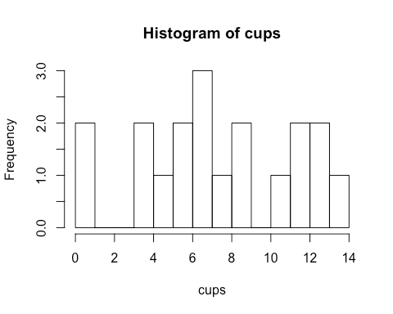

Figure 1: Histogram of cups

Then we sample the number of cups and estimate the quantity of cups with two different ways, estimation for one entire day and estimation split into morning, afternoon and evening (M.A.E). The values and standard variances are as following:

Table 1: Estimation values for entire day and M.A.E

|  |  |  |
| --- | --- | --- |
|  | estimate value | sd |
| entire day.estimate | 1355.639 | 51.99711 |
| M.A.E.estimate | 1321.99 | 38.76349 |

After estimating the number of cups, we use the same method to sample the number of employees and price and calculate revenues with two cups of coffee sample. Then we compare these two profits with histogram as following:

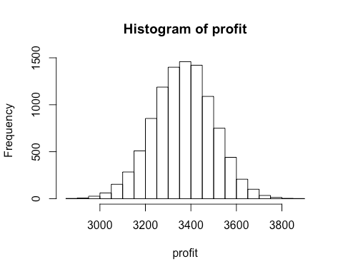

Figure 2: Histogram of profit with entire day.estimate

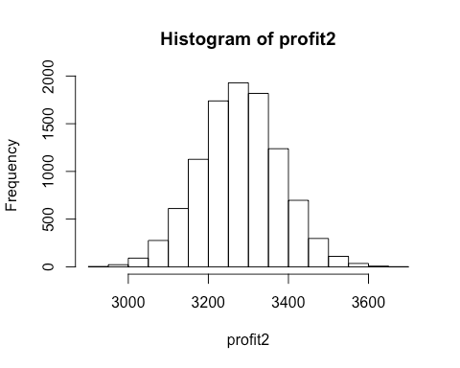

Figure 3: Histogram of profit with M.A.E.estimate

Then we combine these two histogram together to make a comparison.

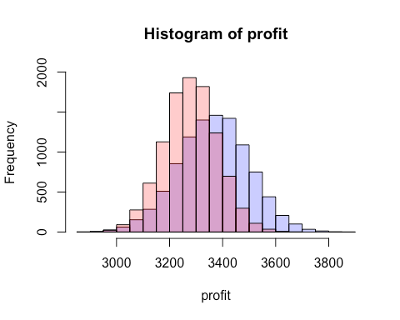

Figure 4: Histogram of profits with two ways

Simultaneously, we do a t-test to see if separating the data by entire day and M.A.E would make a difference. Since the p-value obtained is 0.3, which is much bigger than the confidence level 0.05, it is reasonable to consider that there exists an insignificant difference between these two values. Hence, after the Monte Carlo simulation, we obtain the final consequence about the maximum profit as 3963.41.

5 Appendix

[1] <http://www.payscale.com/research/US/Employer=Starbucks_Corporation>/Hourly_Rate

[2] <http://www.quora.com/How>-much-profit-does-Starbucks-make-on-a-typical-coffee

[3] <http://www.fastfoodmenuprices.com/starbucks-prices/>

6 Code and data

# 1 comparison for estimation values of cups in two ways

data <- read.table("Starbucks.csv", header = TRUE, sep = ",")

data <- data.frame(data)

cups <- data$cups

employees <- data$employees

morning <- 60

afternoon <- 60

evening <- 54

segments <- morning + afternoon + evening

B <- 10000

cup.estimate <- numeric(B)

morning.estimate <- numeric(B)

afternoon.estimate <- numeric(B)

evening.estimate <- numeric(B)

day.estimate <- numeric(B)

cup.average <- numeric(B)

day.average <- numeric(B)

for(i in 1:B)

{random.cups <- sample(cups, segments, replace = TRUE)

cup.estimate[i] <- sum(random.cups)

morning.random <- sample(cups[1:3], morning, replace = TRUE)

afternoon.random <- sample(cups[4:13], afternoon, replace = TRUE)

evening.random <- sample(cups[14:19], evening, replace = TRUE)

morning.estimate[i] <- sum(morning.random)

afternoon.estimate[i] <- sum(afternoon.random)

evening.estimate [i] <- sum(evening.random)

day.estimate[i] <- morning.estimate[i] + afternoon.estimate[i] + evening.estimate[i]}

mean(cup.estimate)

sd(cup.estimate)

mean(day.estimate)

sd(day.estimate)

# 2 Estimation for profits in two ways

# The histogram of cups

data <- read.table("Starbucks.csv", header = TRUE, sep = ",")

prices <- read.table("Starbucks_Prices.csv", header = TRUE, sep = ",")

data <- data.frame(data)

prices <- data.frame(prices)

hist(data$cups,breaks = 10,main = ("Histogram of cups”),xlab=“cups")

# Estimate the revenues in two different ways

cups <- data$cups

employees <- data$employees

morning <- 60

afternoon <- 60

evening <- 54

segments <- morning + afternoon + evening

B <- 10000

cup.estimate <- numeric(B)

morning.estimate <- numeric(B)

afternoon.estimate <- numeric(B)

evening.estimate <- numeric(B)

day.estimate <- numeric(B)

cup.average <- numeric(B)

day.average <- numeric(B)

revenue <- numeric(B)

revenue2 <- numeric(B)

for(i in 1:B)

{random.cups <- sample(cups, segments, replace = TRUE)

cup.estimate[i] <- sum(random.cups)

morning.random <- sample(cups[1:3], morning, replace = TRUE)

afternoon.random <- sample(cups[4:13], afternoon, replace = TRUE)

evening.random <- sample(cups[14:19], evening, replace = TRUE)

morning.estimate[i] <- sum(morning.random)

afternoon.estimate[i] <- sum(afternoon.random)

evening.estimate [i] <- sum(evening.random)

day.estimate[i] <- morning.estimate[i] + afternoon.estimate[i] + evening.estimate[i]}

for(i in 1:B)

{cups.sold <- sample(prices$prices, cup.estimate[i], replace = TRUE)

cups2.sold <- sample(prices$prices, day.estimate[i], replace = TRUE)

revenue[i] <- sum(cups.sold)

revenue2[i] <- sum(cups2.sold)}

# The t-test tests the difference between two profits

u <- runif(10000, min = 8.15, max = 10.92)

u2 <- runif(10000, min = 8.15, max = 10.92)

profit <- (2/3)*revenue - u*mean(employees)

max(profit) # obtain the maximum profit

profit2 <- (2/3)*revenue2 - u2*mean(employees)

max(profit2) # obtain the maximum profit

set.seed(42)

p1<-hist(profit)

p2<-hist(profit2)

plot(p1,col=rgb(0,0,1,1/4),ylim=c(0,2000))

plot(p2,col=rgb(1,0,0,1/4),ylim=c(0,2000),add=T)

profit.ratio <- profit / profit2

t <- (mean(profit.ratio)-1)/(sd(profit.ratio))

1-pt(t, df = 173)

# 3 Observations of cups and employees

|  |  |  |
| --- | --- | --- |
| time | # of cups | # of employees |
| 9:45-50 | 7 | 6 |
| 9:50-55 | 9 | 6 |
| 9:55-10:00 | 9 | 6 |
| 12:30-35 | 13 | 7 |
| 12:35-40 | 14 | 7 |
| 12:40-45 | 11 | 7 |
| 12:45-50 | 6 | 7 |
| 2:50-55 | 13 | 7 |
| 2:55-3:00 | 12 | 7 |
| 3:00-3:05 | 8 | 7 |
| 4:10-15 | 7 | 7 |
| 4:15-20 | 4 | 7 |
| 4:20-25 | 7 | 7 |
| 5:10-15 | 12 | 6 |
| 5:20-25 | 4 | 6 |
| 5:35-40 | 5 | 6 |
| 5:40-45 | 0 | 6 |
| 5:45-50 | 1 | 6 |
| 5:50-55 | 6 | 6 |

# 4 price for each cup of coffee

|  |  |  |  |  |
| --- | --- | --- | --- | --- |
| Price for each cup of coffee | | | | |
| 2.85 | 3.65 | 4.65 | 3.25 | 2.65 |
| 3.45 | 4.25 | 3.75 | 3.95 | 2.95 |
| 3.95 | 4.65 | 3.95 | 4.45 | 2.75 |
| 3.35 | 3.35 | 4.65 | 3.65 | 3.25 |
| 3.95 | 3.95 | 4.95 | 4.25 | 3.75 |
| 4.45 | 4.45 | 2.25 | 4.75 | 4.25 |
| 3.25 | 3.65 | 2.65 | 2.95 | 2.45 |
| 3.95 | 4.25 | 2.95 | 3.45 | 2.95 |
| 4.25 | 4.25 | 3.45 | 3.95 | 3.45 |
| 3.65 | 4.65 | 3.95 | 4.45 | 3.95 |
| 4.25 | 3.75 | 4.45 | 3.95 | 5.95 |
| 4.65 | 4.55 | 4.95 | 4.45 | 3.45 |
| 1.75 | 4.75 | 3.95 | 4.95 | 3.95 |
| 2.1 | 3.45 | 4.45 | 1.75 | 4.45 |
| 2.35 | 4.25 | 4.95 | 2.25 |  |